**Iris Dataset Analysis Report**

1. **Introduction**

| **Project Goal** | *Explore relationships between the Iris flower dataset features (sepal length, sepal width, petal length, petal width) and use Excel for data analysis***.** |  |
| --- | --- | --- |

1. **Dataset Overview**

| **Dataset** | **Iris Flower Dataset** |
| --- | --- |
| **Source** | *From website* |
| **Features** | *Sepal Length, Sepal Width, Petal Length, Petal Width* |
| **Data Cleaning** | *Dataset was clean and ready for analysis.* |

1. **Statistical Analysis**

**3.1. Descriptive Statistics**

| **Feature** | **Mean** | **Median** | **Mode** | **Range** | **Variance** | **Standard Deviation** |
| --- | --- | --- | --- | --- | --- | --- |
| Sepal Length | 5.906666667 | 6.3 | 6.5 | 2.5 | 0.712622222 | 0.84416955 |
| Sepal Width | 3.06 | 3.1 | 3 | 1.3 | 0.0944 | 0.30724583 |
| Petal Length | 3.873333333 | 4.6 | 1.4 | 4.7 | 3.340622222 | 1.82773691 |
| Petal Width | 1.246666667 | 1.5 | 0.2 | 2.3 | 0.642488889 | 0.80155405 |

**3.2. Visualizations**

| **Visualization Type** | **Description** |
| --- | --- |
| **Histograms** | *Histograms of both sepal and petal dimensions has higher are in range 1 -9 frequencies.* |
| **Line Chart** | *Line chart of petal lengths has higher frequency in relation to that of sepal lengths while sepal widths has higher frequency in relation to petal widths.* |
|  |  |

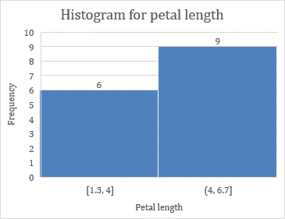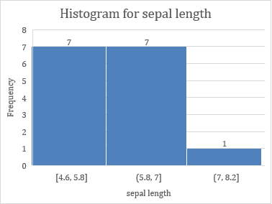

|  | |  | | --- | |  |  |  |  |  |  | |  | | --- | |  |  |  |  |  |  |  |
| --- | --- | --- | --- | --- | --- | --- | --- | --- | --- | --- | --- | --- | --- | --- | --- | --- | --- |
|  |  |  |  |  |  |  |  |  |  |  |  |  |  |  |  |
|  |  |  |  |  |  |  |  |  |  |  |  |  |  |  |  |
|  |  |  |  |  |  |  |  |  |  |  |  |  |  |  |  |
|  |  |  |  |  |  |  |  |  |  |  |  |  |  |  |  |
|  |  |  |  |  |  |  |  |  |  |  |  |  |  |  |  |
|  |  |  |  |  |  |  |  |  |  |  |  |  |  |  |  |
|  |  |  |  |  |  |  |  |  |  |  |  |  |  |  |  |
|  |  |  |  |  |  |  |  |  |  |  |  |  |  |  |  |
|  |  |  |  |  |  |  |  |  |  |  |  |  |  |  |  |
|  |  |  |  |  |  |  |  |  |  |  |  |  |  |  |  |
|  |  |  |  |  |  |  |  |  |  |  |  |  |  |  |  |
|  |  |  |  |  |  |  |  |  |  |  |  |  |  |  |  |
|  |  |  |  |  |  |  |  |  |  |  |  |  |  |  |  |
|  |  |  |  |  |  |  |  |  |  |  |  |  |  |  |  |
|  |  | | | | | |  | | | | | | | | |
|  |
|  |
|  |
|  |
|  |
|  |
|  |
|  |
|  |
|  |
|  |
|  |
|  |

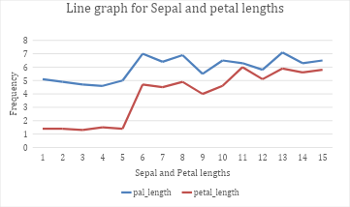

| |  | | --- | |  |  |  |  |  |  |  |  |  |  |  |  |  |  |  |  |
| --- | --- | --- | --- | --- | --- | --- | --- | --- | --- | --- | --- | --- | --- | --- | --- | --- | --- |
|  |  |  |  |  |  |  |  |  |  |  |  |  |  |  |  |  |
|  |  |  |  |  |  |  |  |  |  |  |  |  |  |  |  |  |
|  |  |  |  |  |  |  |  |  |  |  |  |  |  |  |  |  |
|  |  |  |  |  |  |  |  |  |  |  |  |  |  |  |  |  |
|  |  |  |  |  |  |  |  |  |  |  |  |  |  |  |  |  |
|  |  |  |  |  |  |  |  |  |  |  |  |  |  |  |  |  |
|  |  |  |  |  |  |  |  |  |  |  |  |  |  |  |  |  |
|  |  |  |  |  |  |  |  |  |  |  |  |  |  |  |  |  |
|  |  |  |  |  |  |  |  |  |  |  |  |  |  |  |  |  |
|  |  |  |  |  |  |  |  |  |  |  |  |  |  |  |  |  |
|  |  |  |  |  |  |  |  |  |  |  |  |  |  |  |  |  |
|  |  |  |  |  |  |  |  |  |  |  |  |  |  |  |  |  |
|  |  |  |  |  |  |  |  |  |  |  |  |  |  |  |  |  |
|  |  |  |  |  |  |  |  |  |  |  |  |  |  |  |  |  |

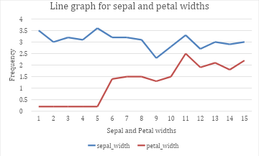

**3.3. Correlation Analysis**

| **Feature Pair** | **Correlation Coefficient** |
| --- | --- |
| Sepal Length vs. Sepal Width | -0.160904206 |
| Sepal Length vs. Petal Length | 0.885449615 |
| Sepal Length vs. Petal Width | 0.82517935 |
| Sepal Width vs. Petal Length | -0.381790485 |
| Sepal Width vs. Petal Width | -0.3578668 |
| Petal Length vs. Petal Width | 0.98603978 |

| **Correlation Matrix** | **Sepal Length** | **Sepal Width** | **Petal Length** | **Petal Width** |
| --- | --- | --- | --- | --- |
| **Sepal Length** | 1 | -0.160904206 | 0.885449615 | 0.82517935 |
| **Sepal Width** | -0.160904206 | 1 | -0.381790485 | -0.3578668 |
| **Petal Length** | 0.885449615 | -0.381790485 | 1 | 0.98603978 |
| **Petal Width** | 0.825179348 | -0.357866782 | 0.98603978 | 1 |

1. **Findings and Conclusion**

| **Findings** | **Key observations and patterns from the statistical analysis and visualizations.** |
| --- | --- |
| **Conclusion** | *Summary of the relationships between the features and its analysis is quite different in the strength of linear relationship.* |

1. **Appendices**

| **Appendix** | **Details** |
| --- | --- |
| Data Cleaning | *Log of any data cleaning steps, such as handling missing values or corrections.* |
| Excel Formulas | *List and explanation of Excel formulas used (e.g., =AVERAGE(), =MEDIAN(), =CORREL()).* |
| Visualizations | *Copies of all visualizations created during the analysis.* |

s